EXP.NO: 4

TO FIND DFT / IDFT OF GIVEN DT SIGNAL

AIM: To find Discrete Fourier Transform and Inverse Discrete Fourier Transform of given digital signal.

Software: MATLAB

THEORY:

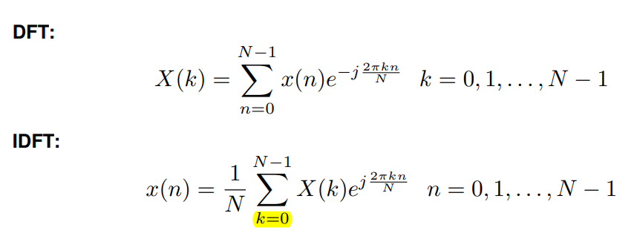

Algorithm:

Step I: Get the input sequence.

Step II: Find the DFT of the input sequence using direct equation of DFT.

Step III: Find the IDFT using the direct equation.

Step IV: Plot DFT and IDFT of the given sequence using matlab command stem.

Step V: Display the above outputs.

## PROGRAM:

clc; close all; clear all;

xn=input('Enter the sequence x(n)'); %Get the sequence from user ln=length(xn); %find the length of the sequence

xk=zeros(1,ln); %initialize an array of same size as that of input sequence ixk=zeros(1,ln); %initialize an array of same size as that of input sequence

%DFT of the sequence

%-----------------------------------------------------

for k=0:ln-1 for n=0:ln-1

xk(k+1)=xk(k+1)+(xn(n+1)*exp((i)*2*pi*k*n/ln)); end

end

%------------------------------------------------------

%Plotting input sequence

%-----------------------------------------------------

t=0:ln-1; subplot(221); stem(t,xn);

ylabel ('Amplitude'); xlabel ('Time Index'); title('Input Sequence');

%---------------------------------------------------------------

magnitude=abs(xk); % Find the magnitudes of individual DFT points

% plot the magnitude response

%------------------------------------------------------------

t=0:ln-1; subplot(222); stem(t,magnitude); ylabel ('Amplitude'); xlabel ('K');

title('Magnitude Response');

%------------------------------------------------------------

phase=angle(xk); % Find the phases of individual DFT points % plot the magnitude sequence

%------------------------------------------------------------

t=0:ln-1; subplot(223); stem(t,phase); ylabel ('Phase');

xlabel ('K');

title ('Phase Response');

%------------------------------------------------------------

%IDFT of the sequence

%------------------------------------------------------------

for n=0:ln-1 for k=0:ln-1

ixk(n+1)=ixk(n+1)+(xk(k+1)*exp(i*2*pi*k*n/ln)); end

end ixk=ixk./ln;

%------------------------------------------------------------

%code block to plot the input sequence

%------------------------------------------------------------

t=0:ln-1; subplot(224); stem(t,ixk);

ylabel ('Amplitude'); xlabel ('Time Index'); title ('IDFT sequence');

%------------------------------------------------------

## Output:

Xn=[1 2 3 4 5]

Xk = 15,-2.50+3.44i,-2.50+0.81i,-2.49-0.81i,-2.49-3.44i

## VIVA QUESTIONS:

* 1. Define signal, Give Examples for 1-D, 2-D, 3-D signals.
  2. Define transform. What is the need for transformation?
  3. Differentiate Fourier transform and discrete Fourier transform.
  4. Differentiate DFT and DTFT
  5. Explain mathematical formula for calculation of DFT.
  6. Explain mathematical formula for calculation of IDFT.
  7. How to calculate FT for 1-D signal?
  8. What is meant by magnitude plot, phase plot, power spectrum?
  9. Explain the applications of DFT.
  10. What are separable transforms?

# Exercise:

1. Find 8-point DFT of the sequence x (n) = [1 2 3 4 4 3 2 1]

**Linear Convolution of Two sequences**

**AIM:** To obtain Linear Convolution of two finite length sequences

## Software: MATLAB THEORY:

Convolution is a mathematical operation used to express the relation between input and output of an LTI system. It relates input, output and impulse response of an LTI system as

y(n)=x(n)∗h(n)

Where y (n) = output of LTI

x (n) = input of LTI

h (n) = impulse response of LTI

By using convolution we can find zero state response of the system.

## Algorithm:

Step I: Give input sequence x[n].

Step II: Give impulse response sequence h(n)

Step III: Find the convolution y[n] using the matlab command conv. Step IV: Plot x[n],h[n],y[n].

## PROGRAM:

clc; clear all; close all;

x1=input('Enter the first sequence x1(n) = '); x2=input('Enter the second sequence x2(n) = '); L=length(x1);

M=length(x2); N=L+M-1;

yn=conv(x1,x2);

disp(‘The values of yn are= ‘); disp(yn);

n1=0:L-1;

subplot(311); stem(n1,x1); grid on; xlabel('n1--->');

ylabel('amplitude--->'); title('First sequence');

n2=0:M-1;

subplot(312); stem(n2,x2); grid on; xlabel('n2--->');

ylabel('amplitude--->');

title('Second sequence');

n3=0:N-1;

subplot(313); stem(n3,yn); grid on; xlabel('n3--->');

ylabel('amplitude--->'); title('Convolved output');

## Output:

Enter the first sequence x1(n) = [1 2 3 4 5]

Enter the second sequence x2(n) = [5 8 3 5 4 6] The values of yn are=

5 18 34 55 80 81 59 59 44 30

## OUTPUT WAVEFORMS:

## 

## VIVA QUESTIONS:

* 1. Explain the significance of convolution.
  2. Define linear convolution.
  3. Why linear convolution is called as a periodic convolution?
  4. Why zero padding is used in linear convolution?
  5. What are the four steps to find linear convolution?
  6. What is the length of the resultant sequence in linear convolution?
  7. How linear convolution will be used in calculation of LTI system response?
  8. List few applications of linear convolution in LTI system design.
  9. Give the properties of linear convolution.
  10. How the linear convolution will be used to calculate the DFT of a signal?

## Exercise:

1. Find the linear convolution of x(n)=[7 5 4 0] and h(n)=[0 3 6 2 9]